CSR Events
YEAR 2019
Activities:

Workshop Conducted Today on Life is a Game, Play It!
Jaipuria Institute of Management, Indirapuram, Ghaziabad organized a workshop on 14th Sep 2019 on “Life is a Game, Play It” in association with Shri Satya Sai Sewa Sangathan. The Institute has initiated this program to incorporate human values among budding managers.

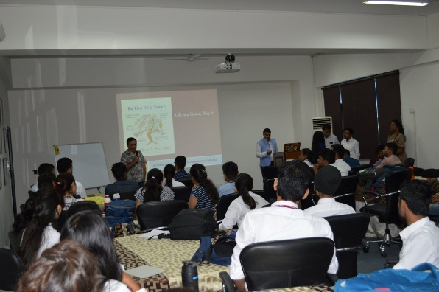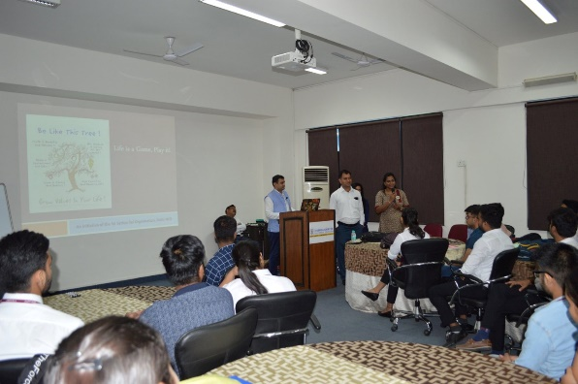

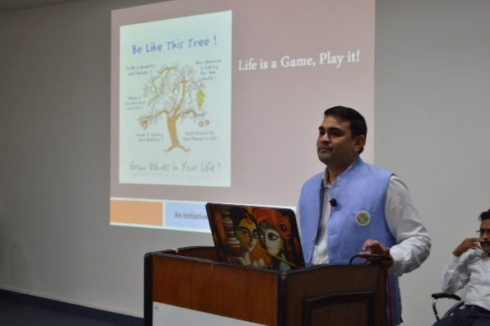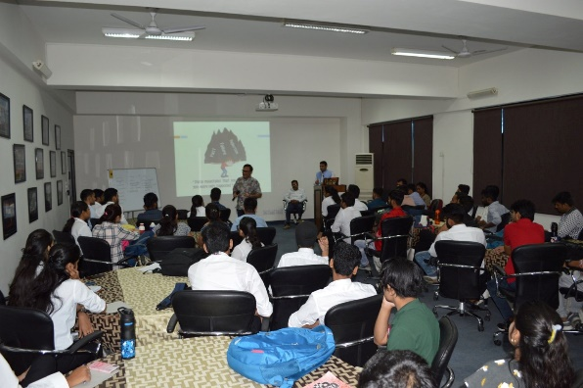

Anti Plastic Campaign
Plastic constitutes to a major portion of the waste in landfills and has also been identified as one of the top litter items in our society. Use of plastic is ruining our beautiful environment and is also posing a serious threat to our health since long. In an attempt to curb further deterioration of the mother Earth and aware people about the harmful effects of Plastic usage, an Anti Plastic Campaign was conducted at Jaipuria Institute of Management, Ghaziabad from 5th September 2019 to 7th September 2019.
This campaign was aimed at inspiring people against the use of plastic and to implant the message of “Say No to Plastic”. This campaign was carried out in three phases: Role play on “Say no to plastic” performed by MBA students, display of posters in and around the campus and organizing awareness campaign in residential societies of Ghaziabad.
The role play communicated the havoc created in the natural habitat because of the extensive use of plastic by the people of our society. Students participated in this drive with full enthusiasm and their posters conveyed some really significant disasters caused by plastic use in

our day to day lives. The awareness campaign and reciting of anti plastic slogans conducted in residential societies of Ghaziabad received overwhelming response from the residents. The residents assured the students to avoid using plastic bags and also propagated this message by displaying the posters on their society notice boards. This drive proved to be a real eye opener for the society and helped creating awareness among many people. The entire idea of restricting the use of plastic turned into a successful event with the energy of youth channelized in the right direction.
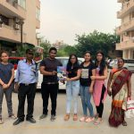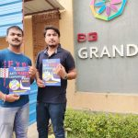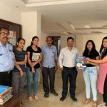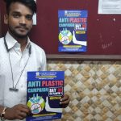

Tree Plantation Drive
With the growing pollution it is important to make environment healthier by planting trees. With this message, Jaipuria Institute of Management, Indirapuram, Ghaziabad organized TREE PLANTATION DAY on August 23, 2019 with full fervor and spirit, as part of the CSR activity. With a vow to save environment the youngsters of the city planted saplings in the college campus. The event was Inaugurated by Prof.(Dr) Daviender Narang, Director, Jaipuria Institute of Management, Indirapuram, Ghaziabad. More than 100 plants were planted in the campus by MBA students and faculty & staff members. The trees planted were selected for their long-term value for providing shade, blossoms and fruit and adding color to the campus. The faculty, staff and students of Jaipuria Institute of Management, Indirapuram, Ghaziabad felt much honored to have each tree planted by them on this occasion. Notably, the plantation drive was organized to encourage youngsters towards healthy life and also to encourage a sense of positivity among students.
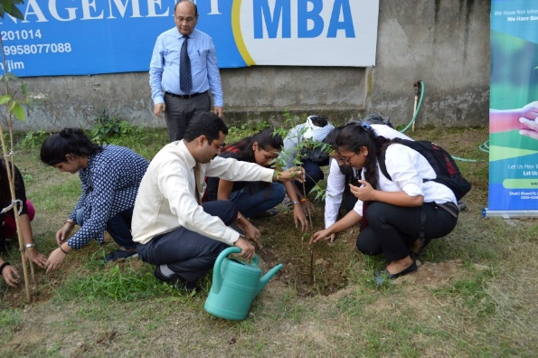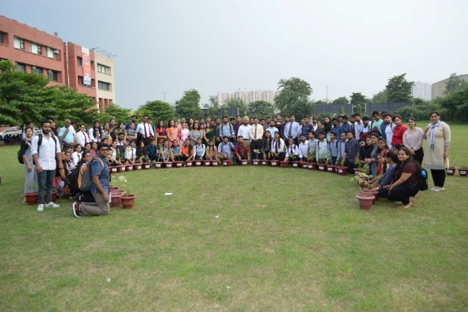

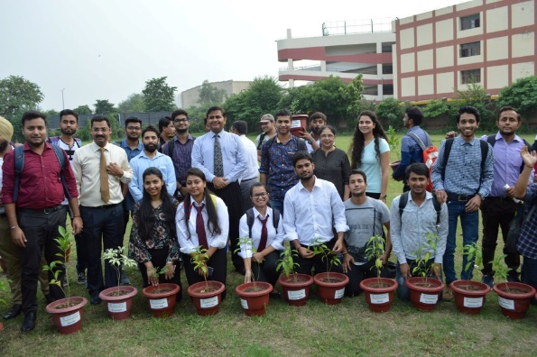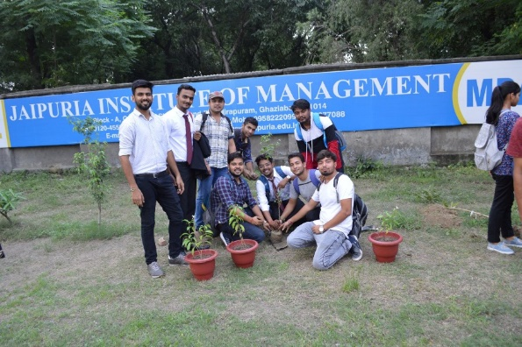

WORKSHOP ON UNIVERSAL HUMAN VALUES AND PROFESSIONAL ETHICS

Jaipuria Institute of Management, Indirapuram, Ghaziabad has organized one day workshop on Universal Human Values and Professional Ethics for MBA Batch 2019-21 during orientation program “Shubharambh 2019” on 4th Aug 2019. Dr. Kumar Sambhav, B.Tech., M.Tech., and Ph.D. from IIT Kanpur conducted the session. More than 150 students and faculty members attended the workshop. During the workshop, he discussed “Samajh“, “Sambandh” and “Samridhhi” i.e. right understanding, relationship, and prosperity. He also discussed how to live in harmony in the current environment. At the end of the session, students and faculty members shared their learnings.

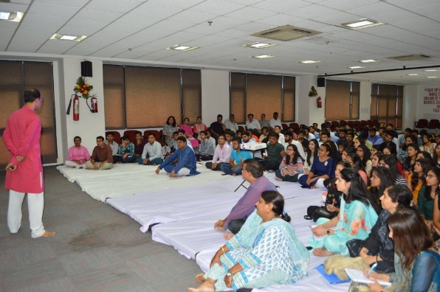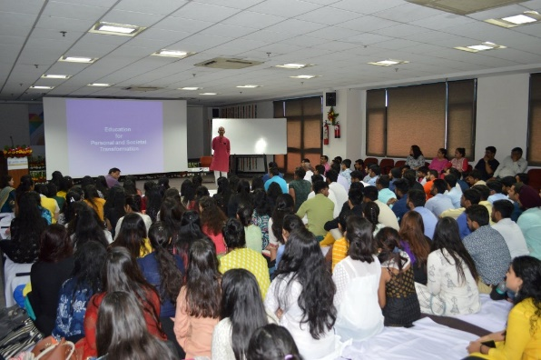

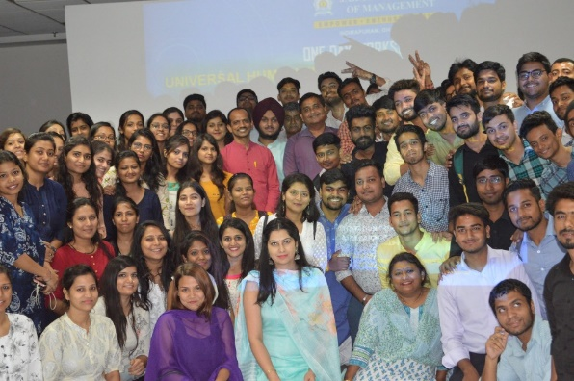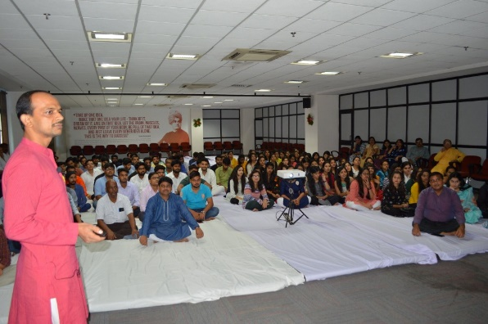

JAIPURIA ACADEMIC EXCELLENCE AWARD
The Institute recognizes the academic achievements of its students in the form of academic excellence awards. These academic excellence awards are given at the end of each academic year based on the performance of the student in the previous academic year. On 3rd August 2019, Jaipuria Academic Excellence Award is given to toppers of MBA Batch 2016-18. The winner Ms. Shreya Saxena received Rs. 1 Lakh, 1st runner up Ms. Snehdeep Saluja received Rs.51,000/– and 2nd Runner up Ms. Shivangi Sharma received Rs. 31,000/-.
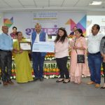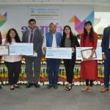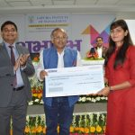

BLOOD DONATION CAMP
Jaipuria Institute of Management, Indirapuram, Ghaziabad organized a blood donation camp on 16th Mach 2019 at its campus in association with Shri Satya Sai Sewa Sangathan .
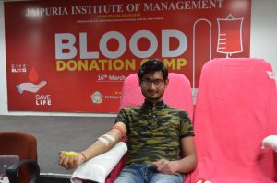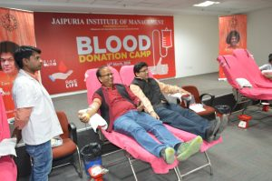
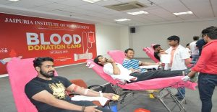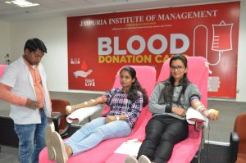

WORKSHOP ON HUMAN VALUES AND ETHICS
Jaipuria Institute of Management, Indirapuram, Ghaziabad organized a holistic program on Human Values and Ethics in association with Shri Satya Sai Sewa Sangathan on 16th Feb, 2019.
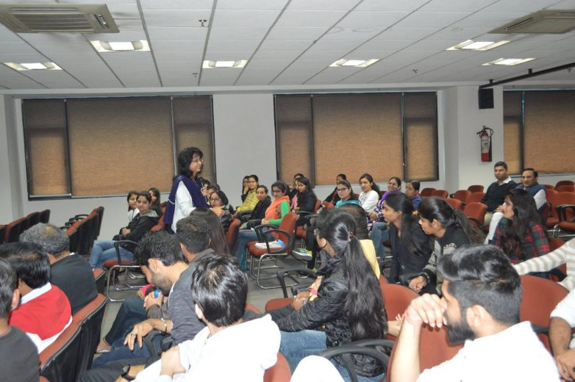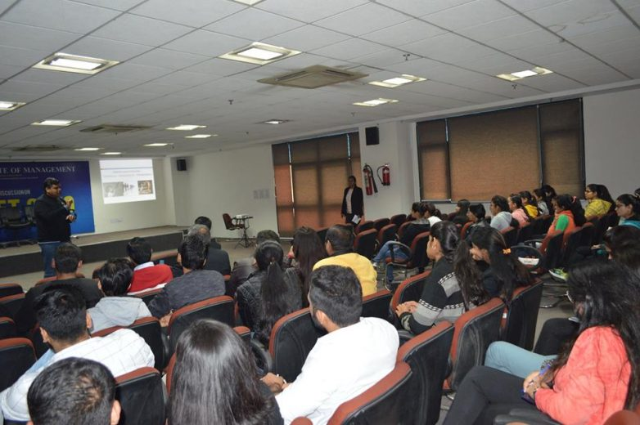

GUEST LECTURE ON HUMAN VALUES AND ETHICS

Jaipuria Institute of Management, Indirapuram, Ghaziabad organized a Guest lecture on Human Values and Ethics in association with Shri Satya Sai Sewa Sangathan on 2nd Feb, 2019

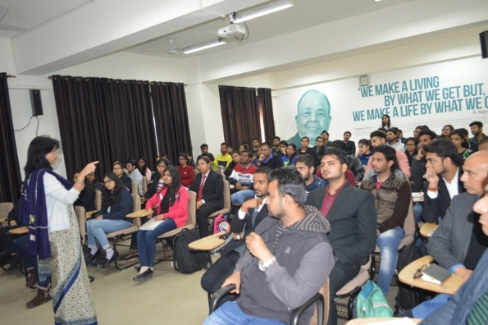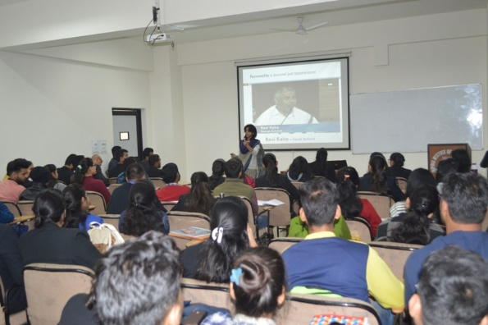

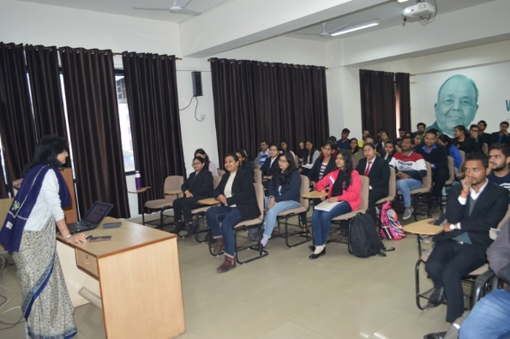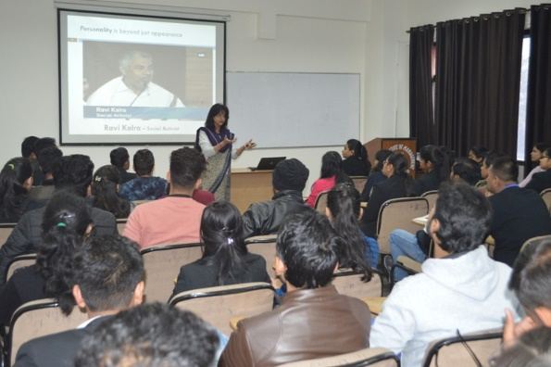

YEAR 2018

Activities:

ANTI-PLASTIC CAMPAIGN
In order to save the environment and for the purpose of Sustainable Development, Jaipuria Institute of Management organized an Anti-Plastic Campaign 2018 in association with Nagar Nigam. MBA I year Students went to various locations in Ghaziabad and distributed cloth bags and motivated people to stop using plastic and GO green. Mr. Yogendra Kumar Yadav, Inspector, Ghaziabad Nagar Nigam spoke on how the prevalence of plastics have become a key environmental issue and the importance of efficient recycling of plastics. Dr. Ashwani Varshney, Dean Students Welfare, Jaipuria Institute of Management, Indirapuram, Ghaziabad said that the idea of the campaign was to create awareness against the use of plastics and inculcate a sense of responsibility among the public to recycle plastics.
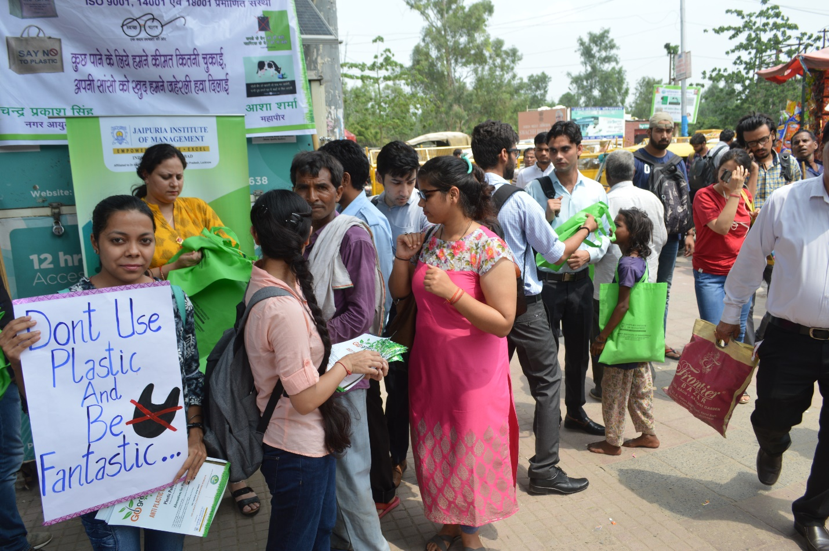
MEDICAL CAMP 2018
Jaipuria Institute of Management (JIM), Ghaziabad – the flagship institute of The Jaipuria Group of Educational Institutions has always considered the vision of helping others an important aspect its foundation. Thus, continuing its commitment of contributing to the society, the management institute organised a specialized medical camp for villagers at Kannavani village, Ghaziabad, Uttar Pradesh on 1st April, 2018 in association with Sri Sathya Sai SevaOrganisation. The objective of the camp was to provide proper health check-up to the villagers. The camp was organized with support from a team of doctors from reputed hospital services. A number of MBA students and the institute staff were present to assist the doctors and help the villagers in each way possible. The institute also provided free medicines and medical facilities to the villagers. The students volunteered in conducting various activities during the camp like patient’s registrations, medical examinations, and medicine distribution.
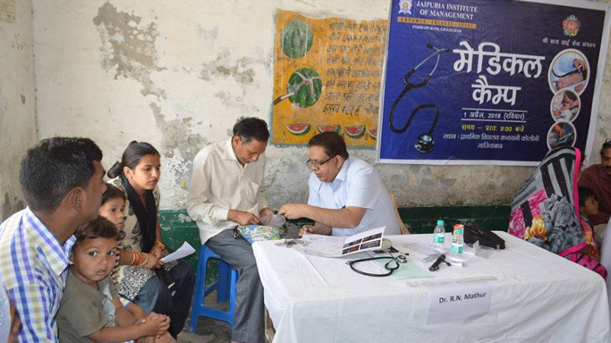
4th International Day of Yoga
Jaipuria Institute of Management, Indirapuram, Ghaziabad celebrated 4th International Day of Yoga on 21st June, 2018 by organizing a special yoga session in which MBA students and faculty members performed various ‘asanas‘ in association with Sri Sathya Sai SevaOrganisation Delhi NCR. The main aim was to raise awareness and ignite a passion for fitness and yoga among the students. This idea was proposed by our Prime Minister, Mr. Narendra Modi. He said, “Yoga is an invaluable gift of India’s ancient tradition. It embodies unity of mind and body; thought and action; restraint and fulfillment; harmony between man and nature; a holistic approach to health and well-being. It is not about exercise but to discover the sense of oneness with yourself, the world and the nature. By changing our lifestyle and creating consciousness, it can help in well-being.” MBA Students and faculty & Staff members were taught various asanas such as Bhujangasana, Ardhachakrasana, Bhadrasana, Vajrasana, KapalBhati, Bhramari, AnulomVilom, ShitaliPranayam, etc. Prof. (Dr) Daviender Narang, Director, Jaipuria Institute of Management, Indirapuram, Ghaziabad said “Yoga is essential for inner and physical growth. It enhances the mental and physical well-being.” He also motivated MBA students to make Yoga an important part of their daily routine to stay fit and healthy.
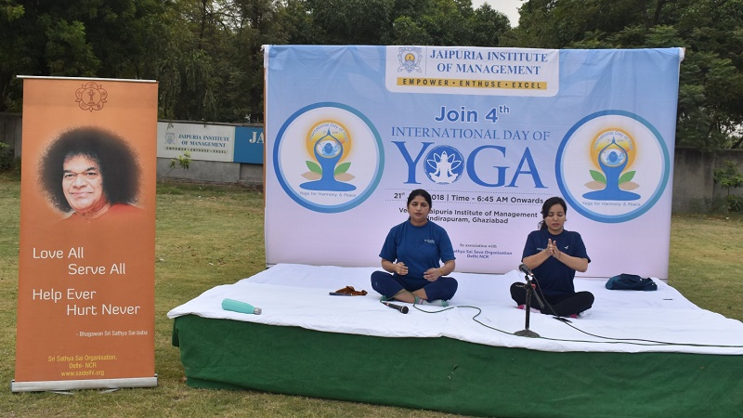

YEAR 2017
ORPHANAGE VISIT ON 7TH APRIL, 2017
On 7th April, 2017, as part of the Corporate Social Responsibility (CSR) Jaipuria Institute of Management, Indirapuram, Ghaziabad provided an opportunity for faculty & staff members and MBA students to visit an orphanage for children with special needs. MBA students and faculty members learn about what the orphanage do, they also got to spend time with the children. From the moment the faculty and students of JIM entered the children’s playroom, the kids immediately bonded to them like glue. Each one of the student and faculty & staff member had a child they had bonded with. Bonding with these kids reinforced the value of humanity for students beyond the point of only learning about its value through taking classes on the subject. Faculty & staff members and MBA students donated clothes and foods during their visit. This experience really struck a chord inside students and made them realise that they should care the society in the future
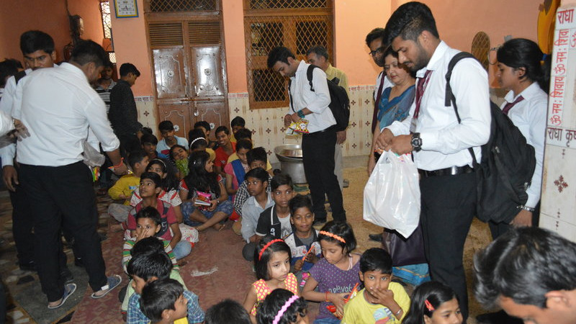

ROLE PLAY COMPETITION ON 1ST APRIL, 2017
Jaipuria Institute of Management, Indirapuram, Ghaziabad organised Role Play Competition on 1st April, 2017 for MBA Students. The institute has initiated to provide a platform to its MBA students to show case their skills and knowledge on very prevalent and serious topics like women harassment, student suicides, road rage and effect of demonetisation on various sectors of economy. It was a very rejuvenating and refreshing day for the students and faculty.
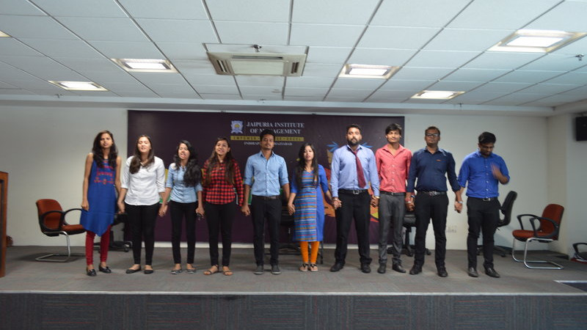
AN OPEN HOUSE DISCUSSION WITH MR. VINOD MALHOTRA TO REVIEW HIS BOOK WRITTEN ON MANAGING LIFE WITH BHAGWAD GITA
Jaipuria Institute of Management, Indirapuram, Ghaziabad organized an open house discussion with Mr. Vinod Malhotra to review his book written on Managing Life with Bhagwad Gita on 17th Nov, 2017.
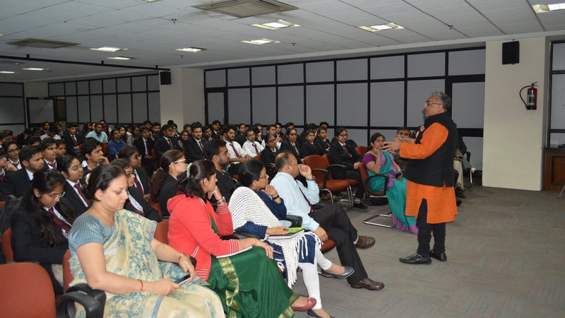

THE SATHYA SAI SEVA ORGANISATION VALEDICTORY PROGRAM
The Sathya Sai SevaOrganisation Valedictory Program took place on 15th April, 2017 at Shri Sathya Sai Auditorium, Lodhi Road, New Delhi.The program was initiated by the Sathya Sai Faculty that gave the complete overview of the modules covered all through the year. Our students shared their life changing experiences which occurred due to the values imbibed in them by the module and the changes that took place in their lives. Students were awarded with certifications. It was a very interactive and reciprocative session.
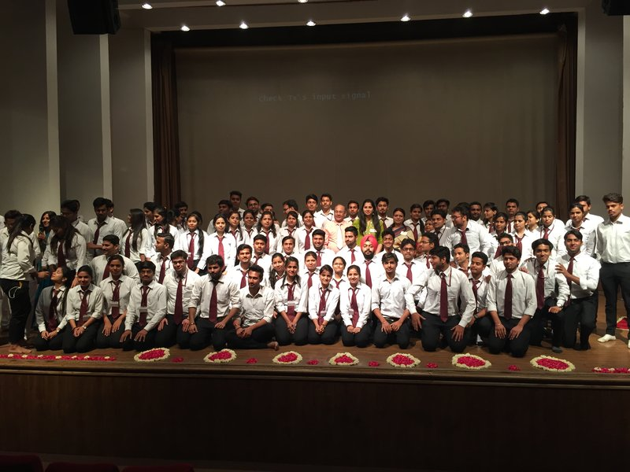
EXCURSION TOUR TO DLF MALL, SECTOR 18, NOIDA
Jaipuria Institute of Management, Indirapuram, Ghaziabad organized an excursion tour to DLF Mall Sector 18, Noida for MBA 1st Year students. Where all high-class brands are available and a place live up to all the Hype and marketing campaign. Interiors design and decoration of every shop is highly attractive and well maintained.
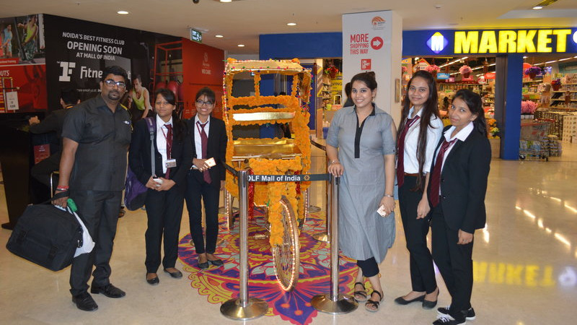
TRAINING COURSE ON HUMAN VALUES AND ETHICS- “LIFE IS A GAME: PLAY IT”
Jaipuria Institute of Management, Indirapuram, Ghaziabad started a training course on Human Values and Ethics- “Life is a Game: Play it” in association with Sri Sathya Sai Seva Organization on 9th Sep, 2017 for MBA I Semester students. This Program focuses on practical life skills and attitudes that appeal to the youth. They are encouraged to find inspiration around them to be good, compassionate, patriotic, self-less and disciplined. It inspires them with examples from the lives of great men and women. It trains them on basic leadership, time and stress management skills and attitudes that will enable them to contribute to the society positively while enriching their own lives.
The objective of this program is to help young students develop wholesome personalities, positive attitudes and help them bring out the inherent human values. The goal is to raise their self-confidence with development of life-skills that empower them to overcome challenges of their everyday lives and to encourage them to seek and find a higher purpose of their existence and further to encourage and develop self-confidence in young students. and inspire through examples of great men and women and establish in the young minds the required human values and to train the students on leadership, stress management and time management skills.
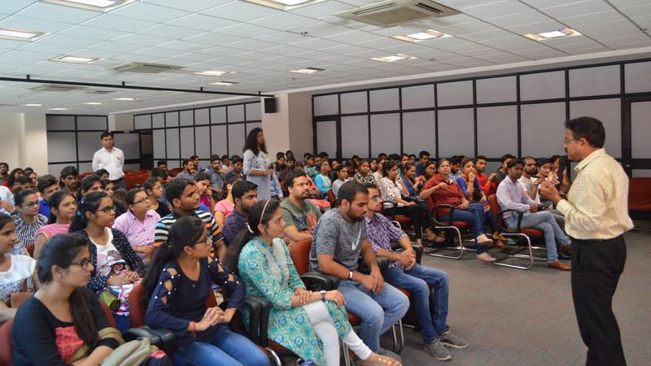

Year 2016

ORPHANAGE VISIT
On 2nd April, 2016, as part of the Corporate Social Responsibility (CSR) Jaipuria Institute of Management, Indirapuram, Ghaziabad provided an opportunity for faculty & staff members and MBA students to visit an orphanage for children with special needs in association with Shri Sathya Sai Seva Organization. The orphanage operates as a foster home for these children.
MBA students and faculty members learn about what the orphanage do, they also got to spend time with the children. From the moment the faculty and students of JIM entered the children’s playroom, the kids immediately bonded to them like glue. Each one of the student and faculty & staff member had a child they had bonded with. Bonding with these kids reinforced the value of humanity for students beyond the point of only learning about its value through taking classes on the subject. Faculty & staff members and MBA students donated clothes and foods during their visit.
This experience really struck a chord inside students and made them realize that they should care the society in the future.
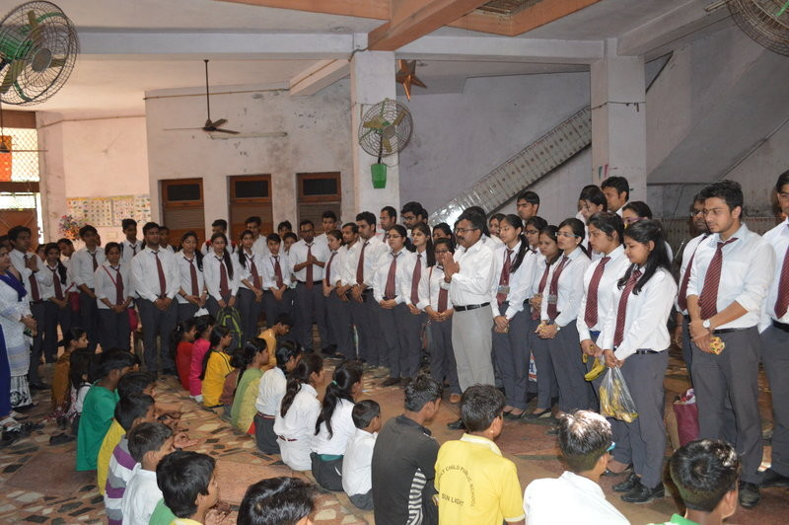

TREE PLANTATION
Jaipuria Institute of Management, Indirapuram, Ghaziabad celebrated TREE PLANTATION DAY on April 2, 2016 with full fervor and spirit, as part of the CSR activity in association with Shri Sathya Sai Seva Organization . Inaugurated by the Mr. Shishir Jaipuria, Chairman, Jaipuria Group of Management Institutions, Prof.(Dr) Daviender Narang, Director, Jaipuria Institute of Management, Indirapuram, Ghaziabad the event started with a ceremonial symbolic walk with students displaying a banner. The event was joined in by an over whelming presence of many students and faculty & staff members. This was followed by Tree Planting drive with the first tree planted by the Mr. Shishir Jaipuria, Chairman, Jaipuria Group of Management Institutions followed by the Prof.(Dr) Daviender Narang, Director, Jaipuria Institute of Management, Indirapuram, Ghaziabad. Faculty and students also planted the trees and the ceremony continued throughout the day. The trees planted were selected for their long term value for providing shade, blossoms and fruit and adding color to the campus. The faculty, staff and students of Jaipuria Institute of Management, Indirapuram, Ghaziabad felt much honored to have each tree planted by them on this occasion.
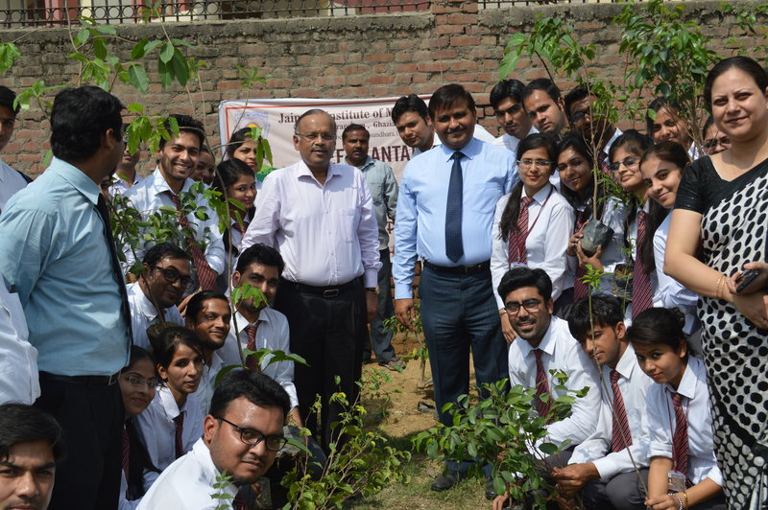

Workshop on HUMAN VALUES
Jaipuria Institute of Management, Indirapuram, Ghaziabad organized a holistic program on Human Values in association with Shri Satya Sai SewaSangathan on 5th March, 2016
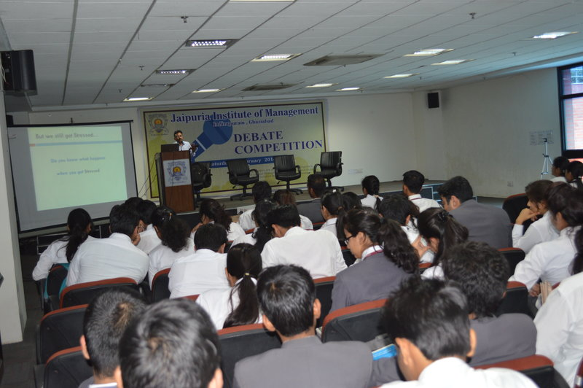

WORKSHOP ON ART OF LIVING
Jaipuria Institute of Management, Indirapuram, Ghaziabad organized a session of “Art of Living” by Mr. Deepak, Coordinator, Art of Living Foundation, Ghaziabad Chapter on 27th February, 2016. He spoke on the benefits of Yoga which has the potential to benefit people from different walks of life. While speaking he stressed that Art of Living teaches mankind as to how to attain long lasting peace and happiness inside human body. He enlightened the audience with the concept of “living and existence”. Everybody merely exists but few are living their life in real terms. Mediatation, Dhayan and Pranayam are essential to synchronize the mind and breathe. The four natures of spiritualism love, peace, joy and enthusiasm comes only through spiritualism.
The workshop on Art of Living ended with an interactive Question and Answer session from faculty members and students of the Institute.
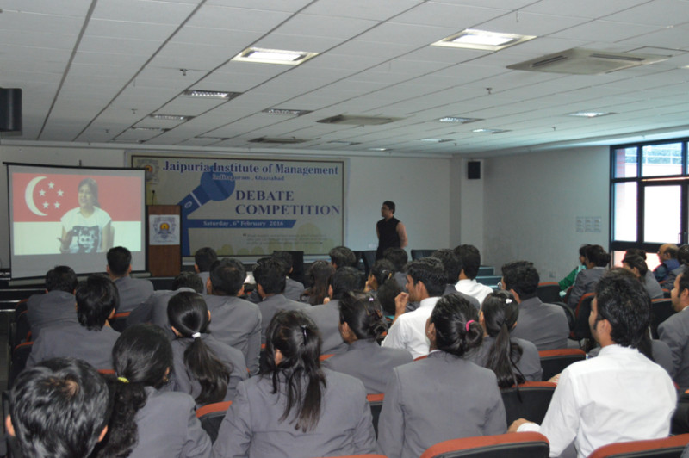

CONVOCATION OF THE COURSE LIFE IS A GAME- PLAY IT
An enlightening event organised by Shri Satya Sai SevaOrganisation at Lodhi road was attended by the MBA students and the faculty of Jaipuria Institute of Management on 9th April, 2016. The event discussed the various modules which were put up in front of students earlier during their ongoing session. An illuminating talk was undertaken by All India President of the organisation influencing the students guiding them the way to achieve success together with the development of spiritual skills. Students were also felicitated with certificates of completion of the course of ‘Life is a game-Play it’.
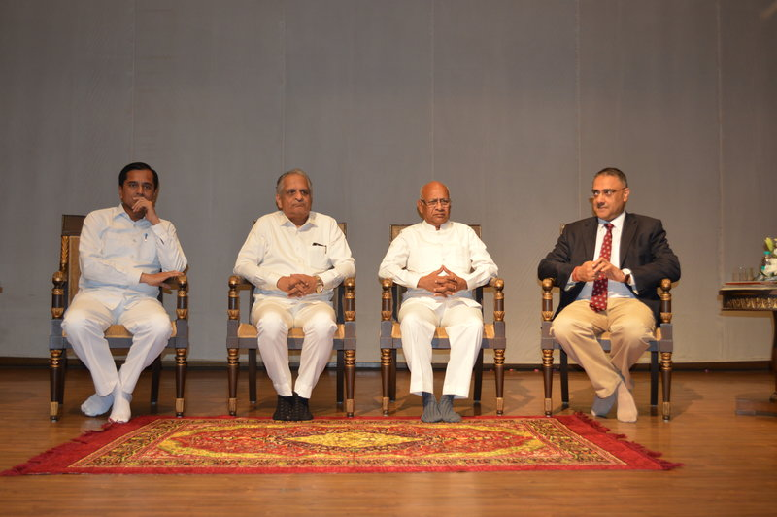

GUEST LECTURE
Jaipuria Institute of Management, Indirapuram, Ghaziabad organised a Guest Lecture on “Life is a Game, Lets Play it.” in association with Shri Satya Sai SewaSangathan on 3rd Sep, 2016.
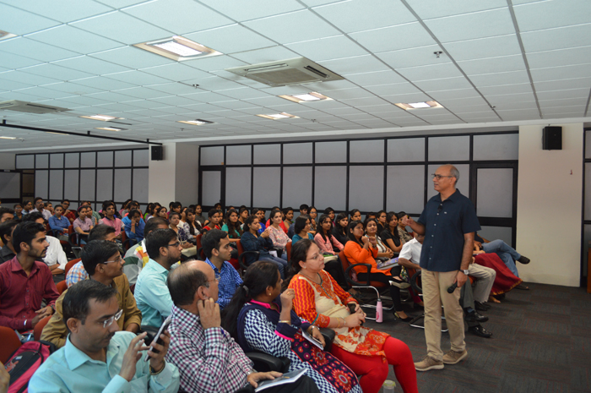

Year 2015

GUEST LECTURE on road safety
Jaipuria Institute of Management, indirapuram, Ghaziabad organized a guest lecture on Road Safety in association with Ghaziabad Traffic Police on 4th Nov, 2015. S P Traffic Mr Amar Singh addressed MBA students on traffic rules and discuss guidelines for road safety. The objective of the session was to increase awareness on traffic rules so that the students can avoid accidents on road.
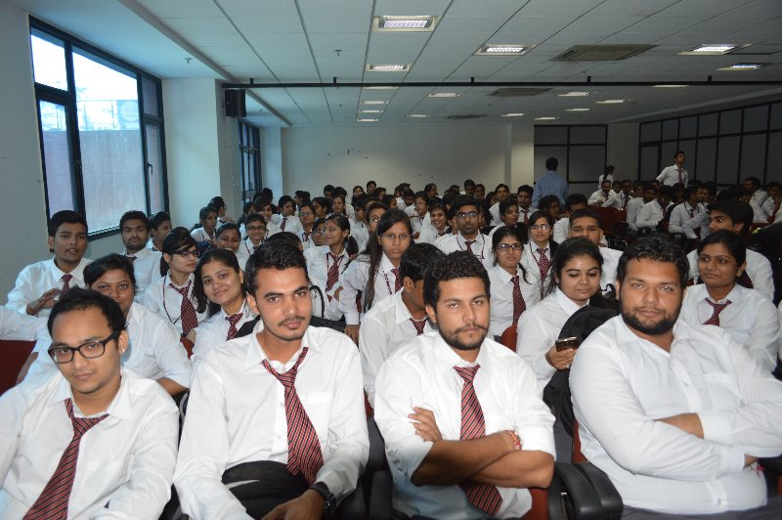

DEBATE COMPETITION
In order to commemorate the birth anniversary of late Dr. A.P.J. Abdul Kalam, the Missile Man of our Nation, students of MBA I Semester and III Semester participated in a debate competition on 17th Oct 2015 (Saturday) at Jaipuria Institute of Management, Indirapuram, Ghaziabad (Formerly located at Vasundhara, Ghaziabad).
Dr. A.P.J. Abdul Kalam no more with us. May his soul rest in peace. He was a true leader and a great contributor to the world of science, and to the technology in India. He was president of India and hence naturally part of the politics of India – yet away from it all. In true sense, he was one of the few men in the country liked by all. We can learn from Dr. Kalam that how can someone become truly iconic to be called “people’s president” that literally everyone across cast and creed, across age group, across states or cultures – everyone loved him.
The debate was undertaken on the social topics like Reservation for women, Is media degrading the society, Impact of social networking sites, women empowerment and increasing number of divorce rates as a consequence, today’s youth and their connection with their parents.
MBA students endowed the stage with their views and perspectives. Great amount of reciprocation from the audiences made the debate even more productive.
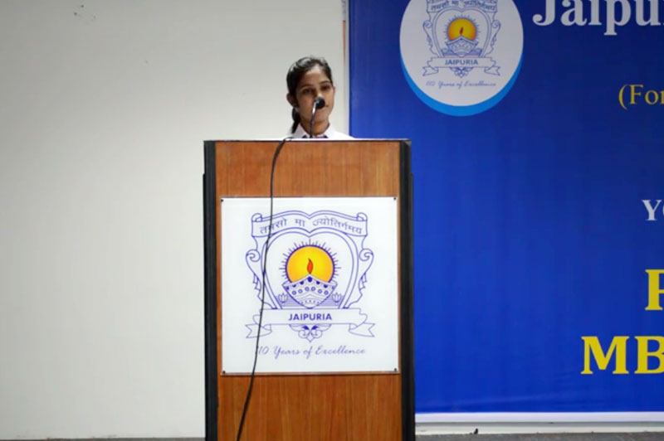

BLOOD DONATION CAMP
Jaipuria Institute of Management,Indirapuram, Ghazibad (Formerly Located at Vasundhara, Ghaziabad) organized a one day blood donation camp in association with Lioness club Delhi Metro Noida on 28th August, 2015 at its premises. The event was inaugurated by Prof (Dr.) Daviender Narang, director of Jaipuria Institute of Management along with Lioness club which was represented by a team of 8 delegates. About 110 students, faculty and staff members of Jaipuria Institute of Management whole heartedly participated in this event. The purpose of this event was not only to collect healthy blood from volunteers for the needy but to also make the youth aware of the importance of positive contribution to the society. This camp is organized every year at Jaipuria institute of Management as part of its CSR initiatives. Prof (Dr.) Daviender Narang addressed the dignitaries and the students on this occasion. He highlighted the achievements of Jaipuriainsititute of management in academic and non-academic field. Ls. Pratima Chaudhary also shared her experiences with the students. Faculty members encouraged students to participate. The camp was coordinated by Dr. Ashwani Varshney, Dr. Ajay Tripathi and Dr Anil Gupta.
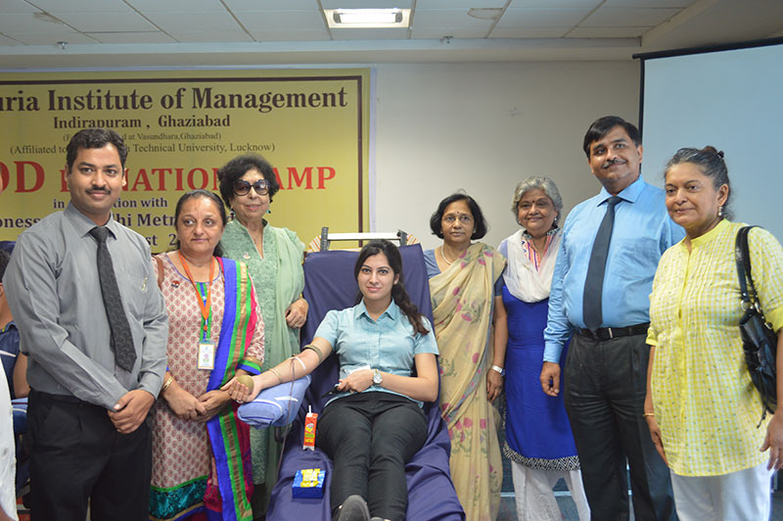

life is a game, play it convocation program
Sri Sathya Sai SevaOrganisation, Delhi-NCR has conducted convocation program after successfully completing the course “Life is a game, play it”, a course on Holistic Life Management through Sri Sathya Sai Human Values Programme in association with Jaipuria Institute of Management, Vasundhara, Ghaziabad on 17th April, 2015.
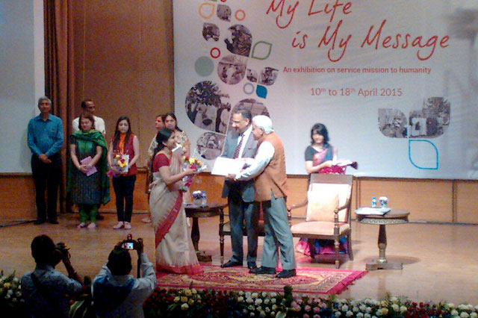

MEDICAL CAMP AND ORPHANAGE VISIT
As part of its Corporate Social responsibility, Jaipuria Institute of Management,VasundharaGhazibad has organized its annual free medical camp at its campus on 5th April 15 in association with Satya Sai SewaSanghathan. Over 150 members from the community benefited from this camp. The medical camp included free diagnosis and consultation as well as dispensing medicines free of charge to the patients. The event was formally organized by the Prof. (Dr) Daviender Narang, director JaipuriaInsitute of MangementVasundhra Ghaziabad. To ensure smooth operation, the Jaipuria Institute of Management Vasundhara provided full infrastructural as well financial support to the visiting doctors. Later on the students and faculty members visited an orphanage and donated clothes, food and stationary to its residents. Local people appreciated the efforts very much. The event was organized by Prof. (Dr) Daviender Narang, Dr. Ashwani Varshney, Mr. Neeraj Dangi and Ms. Bhawna Malik. Besides local community members, college staff and students too were able to avail this benefit.
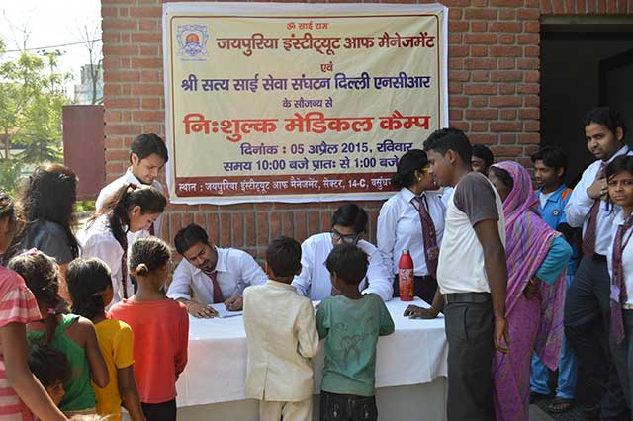

WALK FOR VALUES
MBA students of Jaipuria Institute of Management,Indirapuram Ghaziabad participated in “WALK FOR VALUES” organized by Shri Sathya Sai Association in GIP mall, Noida on 22nd February, 2015. Student of various colleges and schools from Delhi/NCR participated in this mega event. Students were grouped into four segments are like Love, Trust, Non-violence and Peace. Students of Jaipuria Institute of Management, Indirapuram, Ghaziabad participated in peace group. After the walk, there was a musical band “DESI RULE” which performed fabulous music. The walk was coordinated by Dr. Ashwani Varshney and Ms. Bhavana Malik.


WORKSHOP ON HUMAN VALUES
Jaipuria Institute of Management, Vasundhara, Ghaziabad organized a holistic program on Human Values in association with Shri Satya Sai SewaSangathan on 12th Feb, 2015.

Year 2014

SWACHH BBHARAT ABHIYAN
Top MBA Colleges in Delhi – Jaipuria Institute of Management,Vasundhara Ghaziabad Delhi/NCR organized clean drive under the ‘Swatch Bharat’ campaign in association with Satya Sai foundation at Vasundhara (sec-14) on 15th November 2014.
MBA students, faculty and staff using brooms cleared out garbage from roads, drains, chowks, parks and other community areas in the vicinity. The accumulated garbage was disposed by municipal garbage vans. The initiative was taken by director of Jaipura Institute of Management Prof (Dr.) Daviender Narang and coordinated along with Dr. Ashwani Varshney, Dr. Anil Gupta along with other faculty members.

BLOOD DONATION CAMP
Jaipuria Institute of Management,VasundharaGhazibad organized a one day blood donation camp in association with Lioness club Delhi Metro Noida on 29th Aug 2014at its premises. The event was inaugurated by Prof (Dr.) Daviender Narang, director of Jaipuria Institute of Management, Vasundhara along with Lioness club which was represented by a team of 8 delegates. About 110 students, faculty and staff members of Jaipuria Institute of Management, Vasundhara whole heartedly participated in this event. The purpose of this event was not only to collect healthy blood from volunteers for the needy but to also make the youth aware of the importance of positive contribution to the society. This camp is organized every year at Jaipuria institute of Management as part of its CSR initiatives. Prof (Dr.) Daviender Narang addressed the dignitaries and the students on this occasion. He highlighted the achievements of Jaipuriainsititute of management in academic and non-academic field. Ls. Pratima Chaudhary also shared her experiences with the students. Faculty members encouraged students to participate. The camp was coordinated by Dr. Ashwani Varshney, Dr. Ajay Tripathi and Ms. Bhavna Malik. The team from Lioness club were Ls. Pratima Chaudhary, Ls. Latita Srivastava, Ls. Anju Somi, Ls. Rani Gupta, Ls. Arunadhati Sinha, Ls. Manva Nagpal, Ls. Shahil Saxena and Ls. Rajesh Gaur.

life is a game, lets play it VALEDICTORY PROGRAM
On April 5, 2014, our students attended the convocation ceremony of The Sri Sathya Sai SevaOrganisation, on the successful completion of the program titled: Life is a Game, Play it . This was held at Sri Sathya Sai International Centre, New Delhi. The program focussed on imparting the universal message of Human Values and offers modules on Personality Development, Life Skills, Leadership Skills and Key to Relationships amongst other themes.
Shri Sam Pitroda, the Adviser to Prime Minister on Public Information Infrastructure and Innovations and Chairman of National Innovation Council, was the Chief Guest for the occasion.
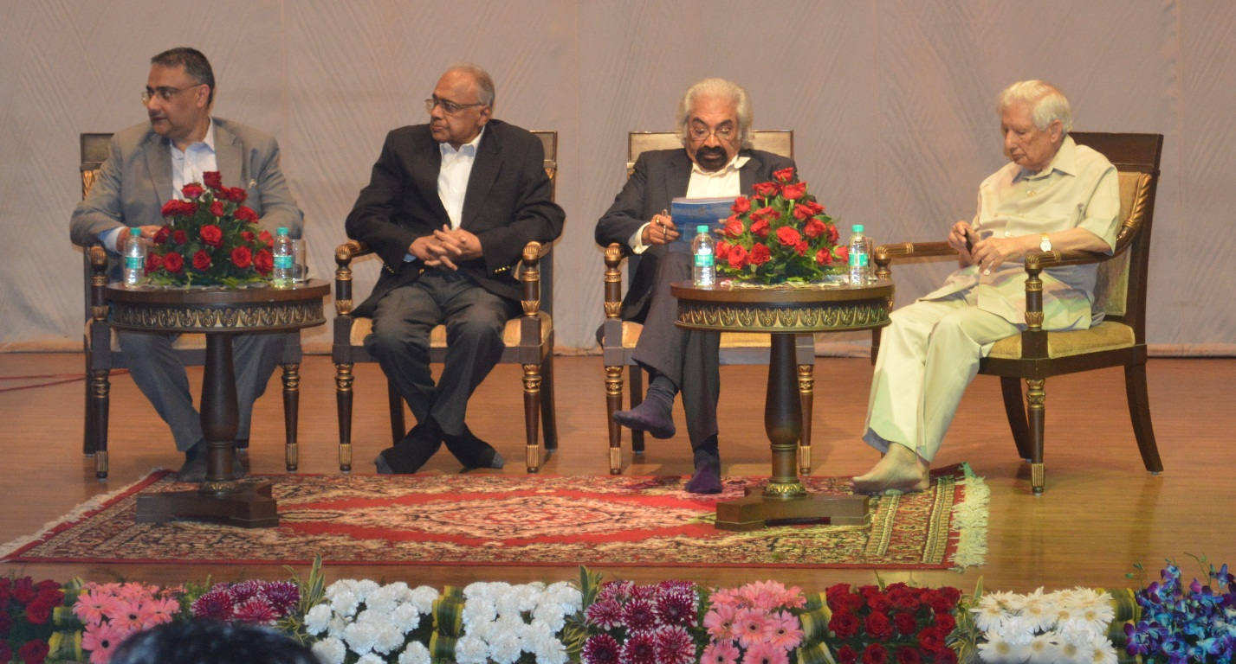

MEDICAL CAMP and orphanage visit
On March 9, 2014, students of Jaipuria Institute of management, Vasundhara, Ghaziabad participated in the Free Medical Camp organized by the Institute in association with Sri Satya Sai Foundation. The camp witnessed a great response from people walking in from the vicinity. The students actively rendered services to the needy and children as well. Parallely, some students also visited Ram Rajya SewaSansthan, an orphanage at Sahibabad. The students distributed food items, clothes, toys and books to the children. They spent a couple of hours interacting with them.
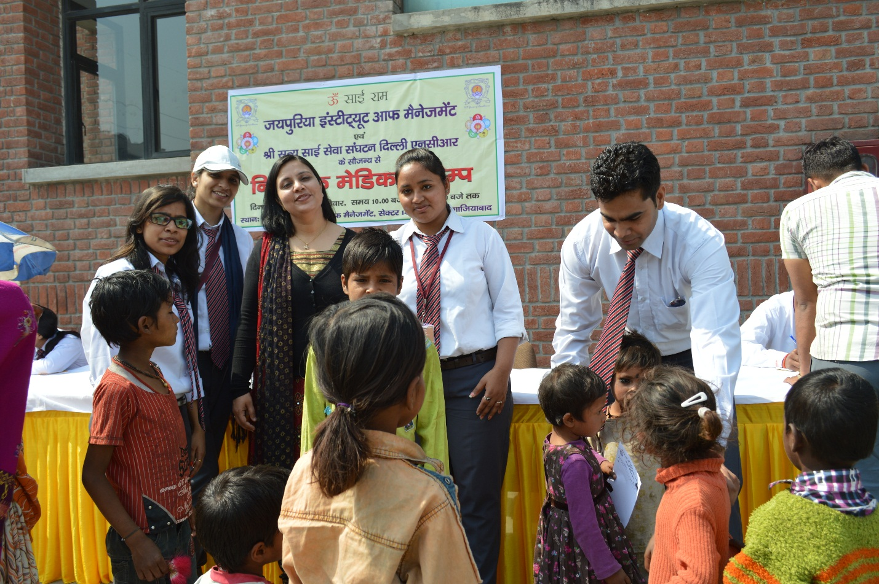

GUEST LECTURE ON “LIFE SKILLS-PLAYING THE GAME”
Jaipuria Institute of Management, Vasundhara, Ghaziabad organized a Guest Lecture on “Life Skills-Playing The Game” in association with Sri Sathya Sai SevaSanghathan on 31st August 2014.
